Radar Safety Report

Nick Mortimer and Graham Symonds

Introduction

CSIRO Marine Research has recently installed a standard X band marine radar at Waterman’s Bar Marine Research Centre. The purpose of the installation is to image the sea surface in an approximate radius of 3 Km. The radar location is shown in Figure 1. The radar will operate 24 hours a day during a sampling campaign. CSIRO Marine Research has been issued a licence from the Australian Communications and Media Authority to operate the radar at this site.

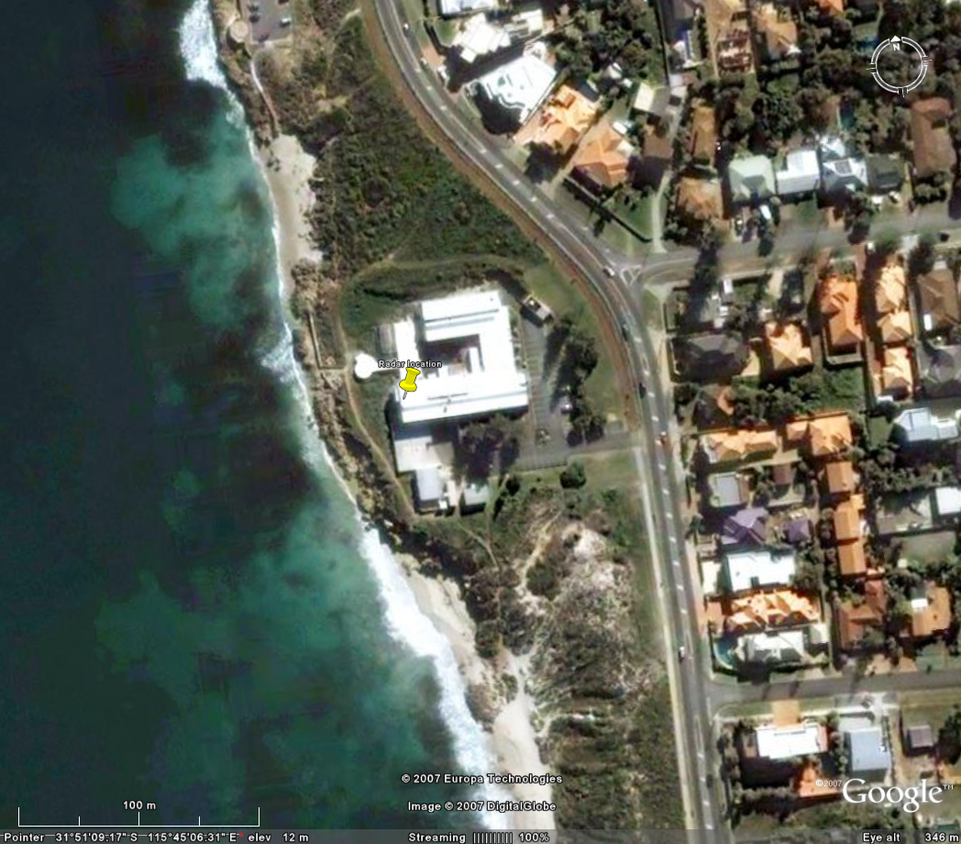

Figure 1: Radar Aerial View

Safety Standards

Non ionizing radiation (radio waves) exposure standards are set by the Australian Radiation Protection and Nuclear Safety Agency (ARPANSA). Maximum levels are set out in: Radiation Protection Series No.3 Maximum Exposure Levels to Radiofrequency Fields 3 KHz to 300 GHz. (ISBN 0-642-79405-7). Should we also mention the general guidelines provided by the Australian Communications Authority? There are two basic classes of exposure, occupational and general public. Table 1 show the restrictions for time averaged and instantaneous power flux density.

Table 1: Basic restrictions for time averaged and instantaneous power flux density.

Exposure Category | Frequency Range | Time Averaged Power Flux Density (W/m²) | Instantaneous Power Flux (W/m²)
Occupational | 6 GHz – 300 GHz | 50 | 50000
General public | 6 GHz – 300 GHz | 10 | 10000

The time averaged power flux is calculated for a fixed point in the earth surface over a six minute period for frequencies below 10 GHz.

The instantaneous power flux density is calculated over any 1 μs period. It is recognized that it is generally not practical to measure RF fields over such a short averaging time and that an estimate can be obtained through knowledge of the temporal characteristics of each specific source.

Radar Specifications Sitex Model 25.9

The radar installed at the site was supplied by Sitex. The specifications for the system are shown in table 2 and 3.

Radars transmit short pulses of high energy microwaves. The transmission time for each pulse is called the pulse width. The number of pulses per minute called the pulse repetition frequency. The duty cycle is the proportion of time during which the radar is operating. The duty cycle gives the relationship between the peak power and the average power. Typically non-coherent radars have a very low duty cycle hence the low average power values.

Table 2: Radar Specifications

Transmit Pulse Width | Pulse Repetition Frequency | Duty Cycle | Average Power | Peak Power
80 nS | 2000 Hz | 0.00016 | 3.12 W | 18.9 kW
300 nS | 1500 Hz | 0.00045 | 8.64 W | 21.1 kW
600 nS | 800 Hz | 0.00048 | 11.38 W | 23.7 kW
1200 nS | 500 Hz | 0.0006 | 14.23 W | 25.1 kW

Table 3: Antenna Specifications

Antenna Type | 9 foot open scanning array (2.74m)
Horizontal Beam Width (H_{bw}) | 0.8º
Vertical Beam Width (V_{bw}) | 25°
Antenna Gain | 30 dB or 1000

Basic exposure calculations

To calculate power levels around the vicinity of the antenna we must first identify the transition point between near field and far field. This point can be approximated by knowledge the antenna geometry. A commonly used rough approximation for this transition point is:

Near field transition point, $R_{T}=\frac{0\text{.}5D^{2}}{λ}=\text{125}m$

$λ$ = Weve length (0.03 m)
D = Longest dimension of the antenna (2.74m)

The power density at a point in space in the far field (distance greater than 125m) of the antenna is given by:

Power density far field,$P_{D}=\frac{P_{t}G_{t}}{4{πR}^{2}}$ (1)
P_{t} = Power transmitted (W)
G_{t} = Antenna gain (30dB or 1000)
R = Range in metres from the antenna

The power density in the near field can be estimated by first finding the power density at the transition point:

Power density at transition point,$P_{0}=\frac{P_{t}G_{t}}{4π(R_{T})^{2}}$

For a rectangular antenna the power at any point in the near field can be estimated by

Power density in near field,$P_{n}=\frac{R_{t}P_{0}}{r}$

Table 4 show the estimated power at ranges from the radar antenna. The red areas show the two locations that fail the standards for the general public. These figures are for a stationary antenna. There is a fail safe mechanism that prevents transmission if the radar antenna is not rotating.

The SCANTER 2001 surface surveillance radar has very similar properties to ours both in peak power and beam width and antenna construction. Figure 2 shows a plot of the limit for general public for the SCANTER 2001 system. Terma state:

Additional safety margins in respect to microwave radiation can be obtained by increasing distances to the radiating antennas. As a rule of thumb, the power density is inversely proportional to the square of the distance from the radiating source. Thus, increasing the distance with a factor of 10 will reduce the power density with a factor of 100. However this is only true in the far fields distance. Complex calculations for the region near the antennas show that:

• Power density is a factor of at least 10 times below the ICNIRP (international standard same as ARPANSA) recommendations for general public for all locations 1 meter or further below the antenna and at any position beyond 7 meter horizontal distance.
• Power density is a factor of at least 10.000 times below the ICNIRP recommendations for general public for all locations 20 meters or further below the antenna.

Furthermore, sector transmission will normally be implemented, stopping transmission for any part of the rotation not covering the sea surface For additional safety SCANTER 2001 transmitters are closed down when antenna rotation is stopped. However, transmission into a stopped antenna can be tolerated without violating the ICNIRP recommendations for general public, for all locations 1 meter or further below the antenna or at any position beyond 10 meters horizontal distance.
Finally, for occupational staff, be aware of safety regulations for rotating machinery.

figure 2: Limit For General Public (source SCANTER 2001 - Surface Surveillance Radar)

Field Measurements

Measurements of the output of the radar using a NARDA 8616 with a 8621B probe we made. Narda Technical Note 2 details how to make a scanning radar measurement in the near field as follows. First the illumination time of the target must be calculated and then the attenuation factor due to the integration time of the probe.

(source : Standards-compliant test of non-ionizingelectromagnetic radiation on radar equipment Narda Saftey Solutions)

No reading was obtained anywhere other than on the roof of the building at a range of approximately 10m a reading on 0.3 W/m² with the radar in high power setting. The integration time of the sensor was estimated a 640mS. At a distance of 10m the attenuation factor was estimated to be 7.7dB or giving a reduction in the displayed by a factor of 6. Hence the measured value was estimated to be between 1.2 and 1.8 W/m². More than five times less than the general public limit, without factoring in the rotation of the antenna. The uncertainty in the reading is due to the lack of information of the true integration time of the sensor. This value is close to the predicted value of 0.9 W/m² . A RAD-Man ESM20 was also used to confirm that the average power was less than 10 W/m² in the vicinity of the antenna.

Table 4: Safe Limits Derived Using Near Field Equation Stationary Radar

Power(rms) | 14.3 | W |  | 3.12 | W
Gain | 1000 |  |  | 1000
P0 | 0.076394373 | W/m² |  | 0.015279 | W/m²
Duty Cycle | 0.0006 |  |  | 0.00016
Range(m) | Stationary Average Power W/m² | Instantaneous Peak W/m² |  | Stationary Average Power W/m² | Instantaneous Peak W/m²
1 | 9.1 | 15173 |  | 2.0 | 12414
2 | 4.6 | 7586 |  | 1.0 | 6207
3 | 3.0 | 5058 |  | 0.7 | 4138
4 | 2.3 | 3793 |  | 0.5 | 3104
5 | 1.8 | 3035 |  | 0.4 | 2483
6 | 1.5 | 2529 |  | 0.3 | 2069
7 | 1.3 | 2168 |  | 0.3 | 1773
8 | 1.1 | 1897 |  | 0.2 | 1552
9 | 1.0 | 1686 |  | 0.2 | 1379
10 | 0.9 | 1517 |  | 0.2 | 1241

Conclusion

We have taken a measured and cautious approach to the situation. It should be noted that these restrictions are very conservative. The site was chosen because the shoreline in the immediate vicinity is rocky with no public beach and limited access due to park restrictions (see figure 1). A public path crosses along the top of the rocky shore about 20m in front but the radar is 8m above the path and the beam passes well over the path.

The radar can be operated in any mode if:

- All persons are more the 10m in the horizontal or 1 m in the vertical from the antenna during operation.
- Warning signs are positioned on the roof of the building and in reception.

As an extra precaution:

- Normal operation is in low power mode (3.12W)
- Radar will not be operated while personnel are on the roof of the building
- Sector scan is used which switches the radar off during the landward part of each revolution
- A security system is being considered for the roof of the building. If the roof zone is entered the radar will be shut down. This is being actively pursued, but is not necessary for the interim period.
- Anchor points have been installed on the roof and safety harnesses are used when working on the radar.

References

